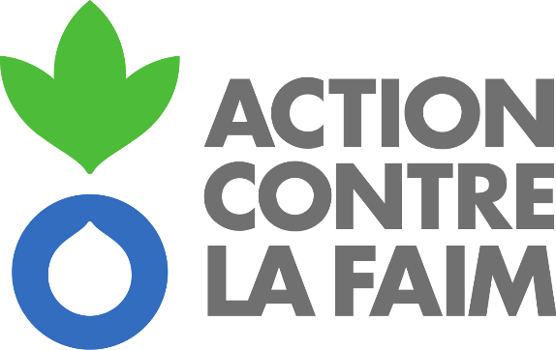 

**Terms of Reference for the Procurement of a consultancy**

**“ACF Psychological interventions implementation manual and toolbox”**

Publication Reference : [FR-PA-DEP-202407]

# **Introduction**

Action Contre la Faim (ACF) seeks a consultant to coordinate and draft a comprehensive implementation manual and toolbox for psychological interventions. This manual will consolidate existing ACF documents and integrate the latest technical frameworks from the World Health Organization (WHO).

# **Objectives and scope**

The primary objective of this contract is to recruit a consultant who will be responsible for:

1. Coordinating the development process of the ACF Psychological Interventions Implementation Manual and Toolbox.
2. Writing the manual and toolbox based on existing ACF documents and the latest WHO technical frameworks.

The consultant will be responsible for the following tasks:

* **Responsibilities**:
  + Draft the guidelines and toolbox.
  + Integrate the ACF EMDR technical note in a specific chapter.
  + Integrate a human resources chapter (with focus on recruitment, testing, induction, and training tools).
  + Integrate chapter and tools on clinical supervision
  + Ensure the document is comprehensive and adheres to the latest guidelines.
* **Outcome**: A detailed technical Guidelines on psychological interventions.
* **Sources**:
  + Existing ACF documents (2017).
  + WHO Psychological Interventions guidelines (2024).
  + ACF protocols excluding EMDR.
  + Existing, yet-to-be-finalized ACF document focusing on emotional stabilization protocol.
  + Integrated Model for Supervision (IMS).
  + EQUIP guidelines (WHO).

# **Deliverables and timeline**

The consultant is expected to deliver the ACF Guidelines on Psychological Intervention and toolbox.

The consultant is expected to complete the deliverables within a specified timeframe, to be determined during the initial phase of the contract. Regular progress reports will be required to ensure timely completion, on November 15th at the latest.

# **Qualifications**

The ideal consultant should have:

* Proven experience in drafting technical documents related to psychological interventions.
* Familiarity with ACF's existing frameworks and WHO guidelines.
* Strong coordination and writing skills both in French and in English.

# **Reporting and Supervision**

The consultant will report to the ACF Head of MHPSS at the HQ and work closely with the technical team to ensure alignment with ACF's standards and guidelines.

# **Application Process**

Interested candidates should submit:

* A cover letter outlining their suitability for the role.
* A detailed project of consultancy and budget.
* A detailed CV.
* Examples of previous work relevant to this consultancy.

# **Evaluation Criteria**

Candidates will be evaluated based on:

* Relevant experience and qualifications.
* Understanding of the scope of work.
* Working proposal with methodology, budget and timeline.
* Quality of previous work samples.

# **Contact Information**

For further details or to submit an application, please contact:

* Guillaume Pégon, Head of MHPSS, [gpegon@actioncontrelafaim.org](mailto:gpegon@actioncontrelafaim.org)

# **Confidentiality**

All documents and information provided during the consultancy are confidential and the property of ACF. The consultant shall not disclose any information without prior written consent from ACF.

# **Terms and Conditions**

The terms and conditions of the contract will be discussed and agreed upon with the selected consultant. The total budget for this consultancy is 10.000 euros. Consultancy is equivalent to one month's full-time work.

# **Deadline for applications**

The deadline for applications is August 25th at midnight. We anticipate shortlisting week commencing September 2nd with a possible round of interviews from the September 9th. The consultancy will start on September 16th and run for 2 months. The consultant will work remotely.